Deacon John Harwood

1921 -

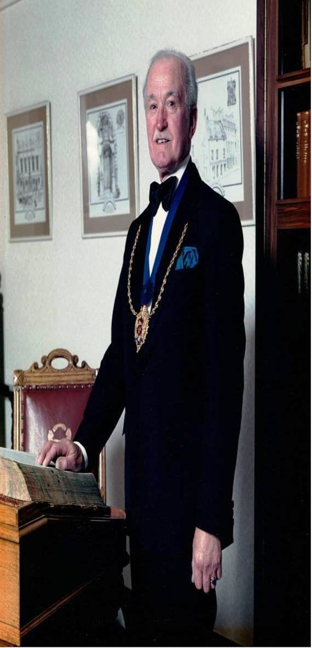

John Edward Harwood was born in Torry, Parish of Nigg on 8 April 1921.

Served during the Second World War and was awarded the following medals:

- 1939-45 Star
- France and Germany Star
- Defence Medal
- Palestine Medal
- 1939-45 Medal
- Territorial Efficiency Medal

John joined the Royal Army Medical Corps in 1939 before transferring to 6th Airborne Division in1944. He recalls buying a book on poetry from a shop in Salisbury in 1944. At the time John was based at nearby Bulford Barracks in training for D-Day. John remained with 6th Airborne until he was demobilised in 1946 while serving in Palestine.

The 6th Airborne Division was the second of two airborne divisions formed by the British Army during the Second World War. Raised in 1943, the division fought in the Normandy landings and the Battle of the Bulge. Thereafter the division participated in Operation Varsity, the second airborne assault over the River Rhine during the war. Afterwards the division advanced north to the Baltic Sea, reaching Wismar by the end of the war.

After the war the 1st Airborne Division was disbanded leaving the 6th as the only airborne division in the British Army. At the end of 1945, the division was named the Imperial Strategic Reserve and deployed to Palestine.

As a strategic reserve, it was envisioned as a mobile peace keeping force, able to respond quickly to any area of the British Empire. However, with Palestine being a British Mandate since the end of the First World War, the Division fulfilled the internal security role until 1948.

The Division was needed to respond to increasing terrorist activity, being responsible for cordons and search operations, guarding convoys and key installations. The troops also had to patrol Arab and Jewish settlements, towns and cities to enforce curfews and deal with rioting by the civilian population and sectarian violence. Several members of the Division were killed and wounded during this time.

John’s first book of poetry became a valued possession and he regularly turns the pages of poetry, time and reflections. This must have had a lasting impression as he began to write his own verse in the late 1980’s

Apart from having a great interest in poetry, John is accomplished as a piano player and singer. He joined the Aberdeen Choral Society in the mid sixties and has been a member for over fifty years. He served for several years on the committee, fulfilled the role of Advertising Manager for concerts etc, and was appointed Honorary President.

John also managed to feature in the Wednesday 2nd November edition of the Evening Express of 1955 (right) as one of the House of Fraser Ltd., prize winners as follows:

“A £10 prize in a national window display competition was won recently by Mr. John Edward Harwood, the store’s display manager for the past four years, who started his training in Aberdeen as a boy.”

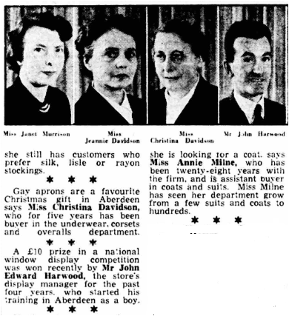

John, always a caring person, served with the Telephone Samaritans from 1964 to 1976. He joined when they began in the old tenement in Huntly Street in Aberdeen before moving to permanent premises in Dee Street.

John certainly takes membership seriously and this is reflected in his membership of the Seven Incorporated Trades of Aberdeen. He is registered in the members of the Shoemakers’ Incorporation as having entered the trade on 10 December 1974 after providing an Essay Piece which is required on entry all new members. The Shoemakers essay is to cut out in leather a pair of shoe uppers which are presented to the Trade at a meeting for inspection. On being approved for membership, John has been an active member for over 50 years before taking a step back in recent times.

He was made a Burgess of Trade in February 1975 and made a Burgess of Guild the same year.

John served as Boxmaster of the Trade being elected to office on 10 October 1983 and 23 October 1984. Thereafter he served as Deacon of the Trade being elected on 22 October 1985 and 21 October 1986 for a second year. He was again elected as Deacon on 11 October 1999 for a further year.

One poem which reflects John’s love of his trade and verse was featured in Leopard Magazine and entitled, How it was….

Picture the Soutar of old
In the lamp’s dim glow
Eyes visionary bright
For top’n-tailed bairns
Sprawled in his cast-off shirts
At the grate where darkening embers smoulder
Annie, hair like damp straw
From the evening rinse at the pump
Mends the ravages of a week’s hard play
On hand-downs

She raises her head
When the last nail is driven home;
Sees the curve of his back:
Rounder now with the demands
Of growing bellies,
Slowly straighten.

“Come awa’ ben, Tam
Yiv daen enough”, she tells him,
Knowing it never is.

John has fond memories of Trinity Hall enjoying “playing the piano at children’s parties which were held at Christmas for children of members from all the Trades”.

In 1973 he attended the Leather Institute Footwear Diploma Course in Northampton and passed the test with honours (86%). Before retirement he worked as a Retail Manager and Company Director of John A. Dunn in Aberdeen.

John was also featured as part of an article in the Leopard Magazine in 1987/88 having just completed two years as Deacon and described as “Director of John A. Dunn’s quality shoe shop in Union Street when it closed in 1982”.

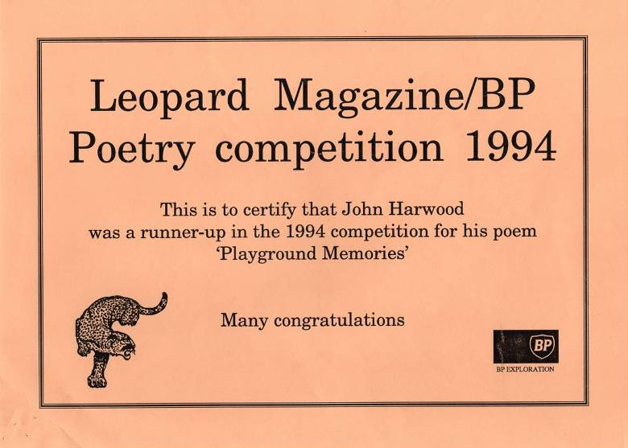

Over the years, John has been published in various magazines including Leopard Magazine and Poetry Now. In 1994, he was shortlisted from 208 entrants in a competition run by BP. Although he did not win the competition, he received £25 as a runner-up for his poem Playground Memories

I remember
Bared knees forever scarred
From non-protective shorts,
Heels pulped digging kypies for bools,
Lost buttons and snapped gallowses
Playing leapfrog and coal-a-bag:
I always got the bully.
Fortified by milk
From third-pint bottles
We crammed outside toilets:
Bet on whose aim was highest.
Through locked gates
‘Hey Mister’ from the shoppie
Charged a penny for Evening Express cone,
Pokey hat stuffed with brokeners:
Loose rich teas, digestives, butters,
Refused in the shop my scornful mothers:

Liquorice straps and locust beans
And thick brown fruit cakes
We called flea cemeteries.

We whistled at skipping girls
Separated by railings and propriety,
Demanded knicker elastic for catapults,
Dubbed pigtailers teacher’s pet.

I remember winter slides
When snow lay thick:
Scary for Miss bus-stop bound
After her day’s oppression:
I remember summer playtime
When jerseys were goalposts
And rules were non-existent.
I remember the handbell swinging Jannie,
Shiny peak ominously on brow.
We’d form lines, laggingly:
Shuffle back to Shakespeare.

The Aberdeen Evening Express on Monday 15th March 1976 carried an interesting article on John’s father, also John Edward Harwood, who was born in Scarborough, moving to Aberdeen as a child. John senior who served in both World Wars was a distinguished seafarer and trawl skipper. During the Second World War he served in the Royal Naval Reserve being made an honorary Lieutenant-Commander of the RNR in Aberdeen. He was given early retirement from active service in 1944 due to a troublesome kneecap which bothered him for the rest of his life.

In September 1939, John senior had just returned to Aberdeen Harbour when he was called south to help build a trawler fleet of fighting fishermen later joined by men from all walks of life. This was the beginning of Britain’s other navy, a collection of trawlers, drifters and whale catchers that became a fighting fleet, the Royal Naval Patrol Service (RNPS). The headquarters in Lowestoft was called the ‘Sparrow’s Nest’ and the RNPS was nicknamed ‘Harry Tate’s Navy’ after a pre-war comedian who was always confounded by new gadgets.

The history of the RNPS can be found in the book ‘Trawlers go to War’ with John senior receiving a mention.

In 1953, John senior was awarded the Decoration for Officers of the Royal Naval Reserve, commonly known as the Reserve Decoration (RD) on HMS Victory at Portsmouth. The medal was awarded to officers with at least fifteen years of active duty.

John senior’s life at sea and his move from Scarborough to Aberdeen is reflected in his son’s poem, Integration:

Integration:

From Scarborough they cam
and Grimsby and Hull,
forming a new community
when the century turned;
bearing strange names,
bringing fresh ways
and lingo!
A different sound:
Torry English locals called it!

They were the trawl fisherman
joining the boom
that steam promised
when the last sail fell
and steel replaced the wooden hull:
and black-rimmed stack,
belching,
smudged the skyline,
fixing a ship’s position.

Dogger knew them, and Faroe;
and Fair Isle’s waters
gave them element
till seas dictated
and dodging failed.
Then Stromness and Kirkwall
were haven,
where pubs thrived
offering island relief.

This rock from my boyhood
is where I willed
a faultless line of sky and sea
grow tiny beads
along its virgin length.
Trawlers, bearing fish
And Fathers!
Bows with silver moustache
Scurrying to market.

